**Balochistan:**

Quaid-e-Azam Residency

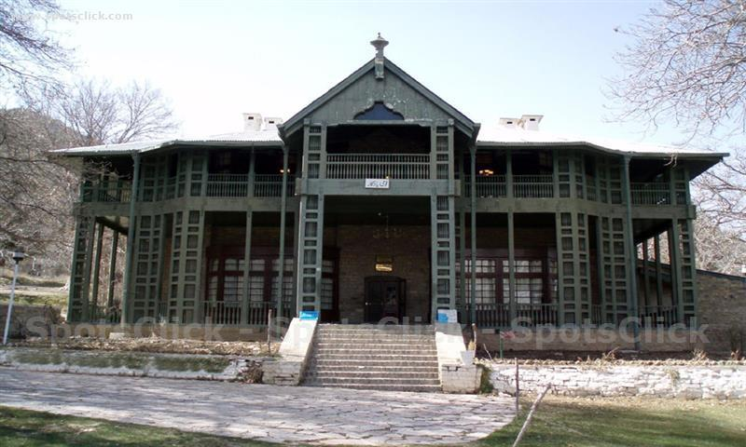

**Quaid-e-Azam Residency** also known as **Ziarat Residency**, is located in Ziarat, Balochistan, Pakistan. It is where Quaid-e-Azam, Muhammad Ali Jinnah spent the last two months and ten days of his life, nursed by A. S. Nathaniel. It is the most famous landmark of the city, constructed in 1892 during the British Raj. The building is a wooden structure, originally designed as a sanatorium before being converted into the summer residence of the agent of the Governor General. It is declared a national monument and heritage site and is of great architectural importance. On 15 June 2013, the Residency was targeted with rockets. The wooden parts of the building were badly affected as a result of the attack. Militants belonging to the Balochistan Liberation Army claimed responsibility. It was badly damaged as a result of the intense attack.[[1]](https://en.wikipedia.org/wiki/Quaid-e-Azam_Residency#cite_note-1) However, the government of Pakistan has vowed to restore the site. The residency was also damaged during the 2008 earthquake. However, despite the wooden structure was badly damaged in the 2013 attack, the concrete structure was standing and the photographs along with the other artifacts were safe and sound.